

INDIAN INSTITUTE OF INFORMATION TECHNOLOGY ALLAHABAD

Subject – Data Mining and Warehousing

Topic – k-Times Markov Sampling for SVMC

Report By -

IIT2018108 – Ravi Kumar Sharma

Assignment :

You have to understand the algorithm proposed in the paper "k -Times Markov Sampling for SVMC ''.
Run the algorithm on the shared given two datasets and show the accuracy in terms of the attached image table: (make one more column in the last name KT_SVM with the new algorithm and give the result).
Try to run the algorithm using different kernels as attached image table.
1) http://host.robots.ox.ac.uk/pascal/VOC/voc2012/ - pascal
2) https://archive.ics.uci.edu/ml/datasets/Letter+Recognition – letter

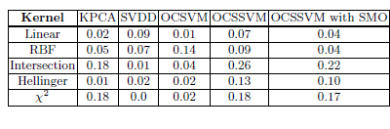

Introduction :

support vector machine classification (SVMC) algorithm are usually based on the assumption of independent and identically distributed (i.i.d.) samples.

Instruction to run the code

step #1. open the code in google colab or jupyter notebook.
step #2. upload the required dataSet uploaded with this code.
step #3. run the all the codes of whole block serialWise.
step #4. Look at the result or output of the code of all sections.

Algorithm 1 : Algorithm 2 :

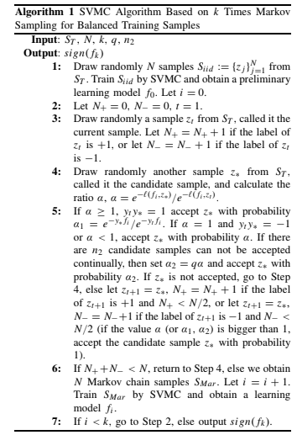
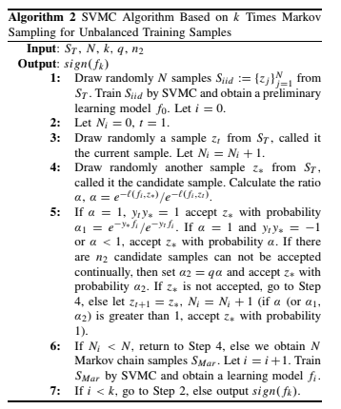

Results :

1. letter-recognition dataset

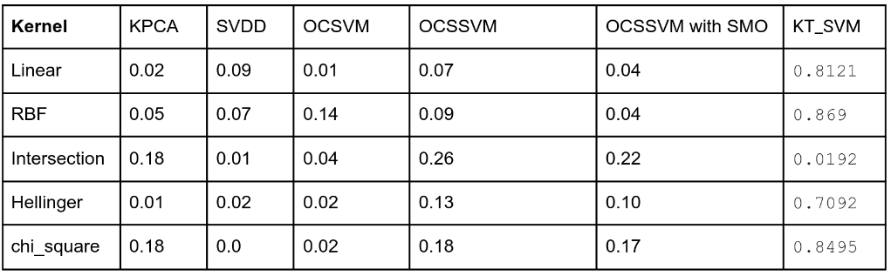

2. Pascal dataset

